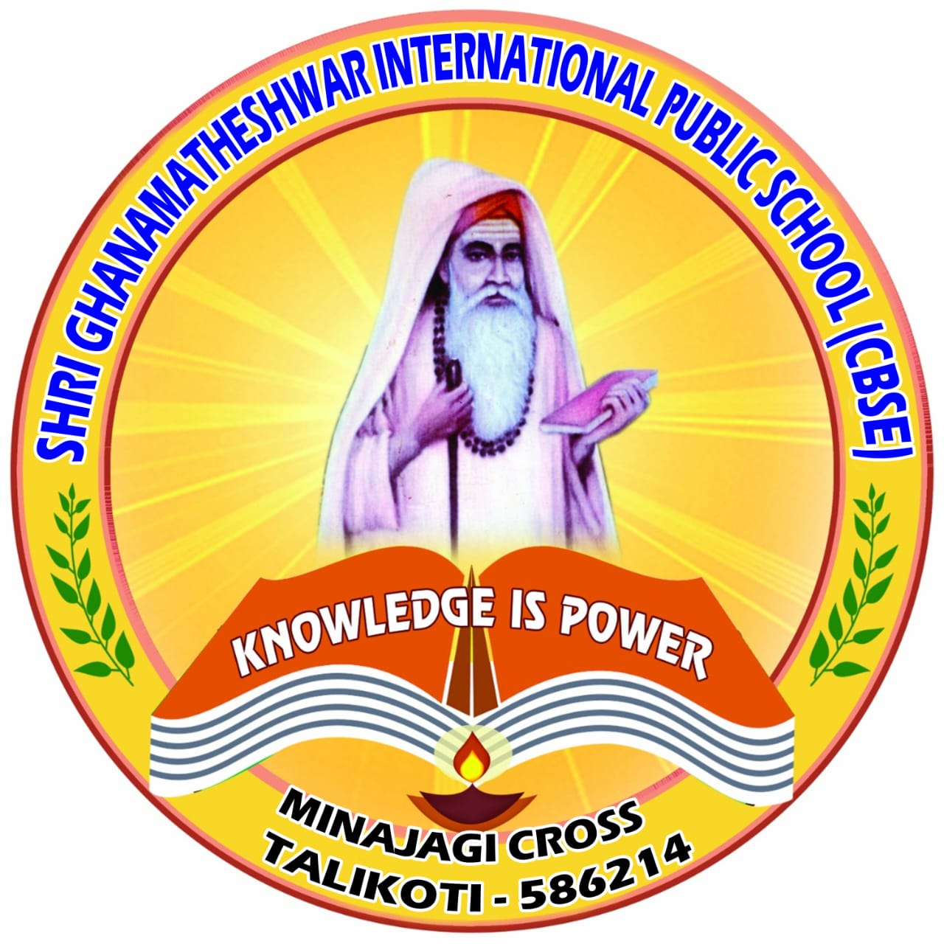 |  | SHRI GHANAMATHESHWAR INTERNATIONAL PUBLIC SCHOOL  ACADEMIC CALENDER 2023-2024
June  2023 |  | Opening Day Bridge Course Environmental Day Vidyarambham & Reopening of Kg Father’s Day  Yoga Day Story Telling Competition(1-5),Pick & Speak(6-8)  Bakrid
Mon | Tue |  | Wed | Thu | Fri | Sat | Sun
 |  |  |  | 1  Reopening Day | 2 | 3 | 4
5  Environmental Day | 6 |  | 7  Vidyarambham Reopening of kg | 8 | 9 | 10 | 11
12 | 13 |  | 14 | 15 | 16 | 17 | 18
19  Father’s Day | 20 |  | 21  Yoga Day | 22 | 23 | 24  S.T.C  P.A.S | 25
26 | 27 |  | 28 | 29  Bakrid | 30

 |  | SHRI GHANAMATHESHWAR INTERNATIONAL PUBLIC SCHOOL
July  2023 |  | National Doctor’s Day Competition  Pink Day for Kg Unit Test-1  Muharram
Mon | Tue |  | Wed | Thu | Fri | Sat | Sun
 |  |  |  |  |  | 1  National Doctor’s Day | 2
3 | 4 |  | 5 | 6 | 7 | 8  Competition | 9
10 | 11 |  | 12 | 13 | 14 | 15  PinkDay | 16
17 | 18 |  | 19 | 20 | 21 | 22 | 23
24 | 25 |  | 26  Unit Test-1 | 27  Unit Test-1 | 28  Unit Test-1 | 29  Unit Test-1 | 30
31

 |  | SHRI GHANAMATHESHWAR INTERNATIONAL PUBLIC SCHOOL
August 2023 |  | Green Day P.T.M-1 Independence Day  Nagara Panchami Varmahalakshmi Puja National Sports Day  Raksha Bandhan
Mon | Tue |  | Wed | Thu | Fri | Sat | Sun
 | 1 |  | 2 | 3 | 4 | 5  Green Day | 6  P.T.M
7 | 8 |  | 9 | 10 | 11 | 12 | 13
14 | 15  Independence Day |  | 16 | 17 | 18 | 19 | 20
21  Nagara Panchami | 22 |  | 23 | 24 | 25  Varmahalakshmi  Puja | 26 | 27
28 | 29  National Sports Day |  | 30 | 31  Raksha Bandhan

 |  | SHRI GHANAMATHESHWAR INTERNATIONAL PUBLIC SCHOOL
September 2023 |  | Teacher’s Day Krishnajanmasthami(KG-1st) Periodic Test-1  Ganesh Chaturti Yellow Day Celebration Id-e-Milad
Mon | Tue |  | Wed | Thu | Fri | Sat | Sun
 |  |  |  |  | 1 | 2 | 3
4  Labor Day | 5  Teacher’s Day |  | 6  Krishnajanmasthami | 7  Periodic Test-1 | 8  Periodic Test-1 | 9  Periodic Test-1 | 10  Periodic Test-1
11  Periodic Test-1 | 12  Periodic Test-1 |  | 13  Periodic Test-1 | 14 | 15 | 16 | 17
18  Ganesh Chaturti | 19 |  | 20 | 21 | 22 | 23  Yellow Day Celebration | 24
25 | 26 |  | 27 | 28  Id-E-Milad | 29 | 30

 |  | SHRI GHANAMATHESHWAR INTERNATIONAL PUBLIC SCHOOL
October 2023 |  | Gandhi Jayanti Mid Term Exam Dusshera  Reopening P.T.M-2
Mon | Tue |  | Wed | Thu | Fri | Sat | Sun
 |  |  |  |  |  |  | 1
2  Gandhi Jayanti | 3  Mid Term |  | 4  Mid Term | 5  Mid Term | 6  Mid Term | 7  Mid Term | 8
9  Mid Term | 10  Dusshera Holidays |  | 11 | 12 | 13 | 14 | 15
16 | 17 |  | 18 | 19 | 20 | 21 | 22
23 | 24 |  | 25  Reoprning | 26 | 27 | 28 | 29  P.T.M-2
30 | 31

 |  | SHRI GHANAMATHESHWAR INTERNATIONAL PUBLIC SCHOOL
November 2023 |  | Karnataka Rajyotsava Diwali & Children’s Day Celebration  Diwali Red Day Celebration & Indoor Games (6th to 10th)  Annual Sports Day Unit Test-2
Mon | Tue |  | Wed | Thu | Fri | Sat | Sun
 |  |  | 1  Karnataka Rajyotsava | 2 | 3 | 4 | 5
6 | 7 |  | 8 | 9 | 10  Diwali &Children’s Day | 11 | 12
13 | 14  Diwali |  | 15 | 16 | 17 | 18  Red Day &Indoor Games | 19
20 | 21 |  | 22 | 23 | 24 | 25  Annual Sports Day | 26
27  Unit Test-2 | 28 |  | 29 | 30

 |  | SHRI GHANAMATHESHWAR INTERNATIONAL PUBLIC SCHOOL
December 2023 |  | Field Trip Annual Day Celebration  Christmas &Winter Holidays
Mon | Tue |  | Wed | Thu | Fri | Sat | Sun
 |  |  |  |  | 1 | 2  Field Trip | 3
4 | 5 |  | 6 | 7 | 8 | 9 | 10
11 | 12 |  | 13 | 14 | 15 | 16 | 17
18 | 19 |  | 20 | 21 | 22 | 23  Annual Day | 24  Winter Holidays
25  Christmas | 26 |  | 27 | 28 | 29 | 30 | 31

 |  | SHRI GHANAMATHESHWAR INTERNATIONAL PUBLIC SCHOOL
January 2024 |  | Fruit Salad Day & New Year Celebration Periodic Test-2  Makarasankranti P.T.M-3  Republic Day
Mon | Tue |  | Wed | Thu | Fri | Sat | Sun
1  Fruit Salad Day and New Year | 2 |  | 3 | 4 | 5 | 6 | 7
8 | 9 |  | 10 | 11 | 12 | 13 | 14
15  Makarsankranti | 16  Periodic Test-2 |  | 17  Periodic Test-2 | 18  Periodic Test-2 | 19  Periodic Test-2 | 20  Periodic Test-2 | 21
22  Periodic Test-2 | 23 |  | 24 | 25 | 26  Republic Day | 27 | 28  PTM-3
29 | 30 |  | 31

 |  | SHRI GHANAMATHESHWAR INTERNATIONAL PUBLIC SCHOOL
February 2024 |  | GrandParent’s Day Celebration Preparatory Exams 10th.  Feb last Annual Exams for 10th Annual Exams 8th and 9th.
Mon | Tue |  | Wed | Thu | Fri | Sat | Sun
 |  |  |  | 1 | 2 | 3 | 4
5 | 6 |  | 7 | 8 | 9 | 10  GrandParent’s Day | 11
12 | 13 |  | 14 | 15 | 16 | 17 | 18
19  Annual 8th and 9th.  Preparatory(10th) | 20  Annual 8th and 9th.  Preparatory(10th) |  | 21  Annual 8th and 9th.  Preparatory(10th) | 22  Annual 8th and 9th.  Preparatory(10th) | 23  Annual 8th and 9th.  Preparatory(10th) | 24  Annual 8th and 9th.  Preparatory(10th) | 25
26 | 27 |  | 28 | 29
 |  | SHRI GHANAMATHESHWAR INTERNATIONAL PUBLIC SCHOOL
March 2024 |  | Annual Exam (1st to 7th) Vacation Classes for Junior 9th and 10th
Mon | Tue |  | Wed | Thu | Fri | Sat | Sun
 |  |  |  |  | 1 | 2 | 3
4 | 5 |  | 6 | 7 | 8 | 9 | 10
11 | 12 |  | 13 | 14 | 15 | 16 | 17
18 | 19 |  | 20  Annual Exams | 21 | 22 | 23 | 24
25 | 26 |  | 27 | 28 | 29  Good Friday | 30 | 31

 |  | SHRI GHANAMATHESHWAR INTERNATIONAL PUBLIC SCHOOL
April  2024 |  | Result Day Holidays for 9th and 10th.
Mon | Tue |  | Wed | Thu | Fri | Sat | Sun
1 | 2 |  | 3 | 4 | 5 | 6 | 7
8 | 9 |  | 10  Result Day | 11 | 12 | 13  Holidays(9th and 10th.) | 14
15 | 16 |  | 17 | 18 | 19 | 20 | 21
22 | 23 |  | 24 | 25 | 26 | 27 | 28
29 | 30

 |  | SHRI GHANAMATHESHWAR INTERNATIONAL PUBLIC SCHOOL
May  2024 |  | Important Information
Mon | Tue |  | Wed | Thu | Fri | Sat | Sun
 |  |  | 1 | 2 | 3 | 4 | 5
6 | 7 |  | 8 | 9 | 10 | 11 | 12  Mother’s Day
13 | 14 |  | 15 | 16 | 17 | 18 | 19
20 | 21 |  | 22 | 23 | 24 | 25 | 26
27  Memorial’s Day | 28 |  | 29 | 30 | 31

